**Front End Web Development**

* HTML
* CSS
* Bootstrap
* JavaScript
* jQuery
* Angular

**Setup Environment for Working with Web Application:**

* Download and install “Node.js” on your PC
  + Node.js will provide a “Package Manager” tool “NPM [Node Package Manager]”
  + Package Manager is a software tool used by web developers to download and install various libraries required for project.
  + There are various package manager tools like
    - **NPM**
    - Yarn
    - Bower
    - Grunt
    - Growl
    - NuGet
    - RubyGems etc..
  + Download **Node.js 14x version** for NPM  
    [**https://nodejs.org/en/download/**](https://nodejs.org/en/download/)
  + Install on your PC
  + Open Command Prompt [Run – cmd]  
    C:\> node -v  
    C:\> npm -v

**Download and install “Visual Studio Code” editor**

* Editor is a software tool, which is used by developers for
  + Building
  + Debugging
  + Testing
  + Deploying applications
* IDE [Integrated Development Environment]
* There are various editors   
  [**https://editorconfig.org/**](https://editorconfig.org/)
* **Download and install “Visual Studio Code” editor**

[**https://code.visualstudio.com/**](https://code.visualstudio.com/)

**Add following extensions to “Visual Studio Code”**

* Open Visual Studio Code
* Go to “Extensions” button in left navigation bar.
* Search for following extensions and install
  + **Live Server**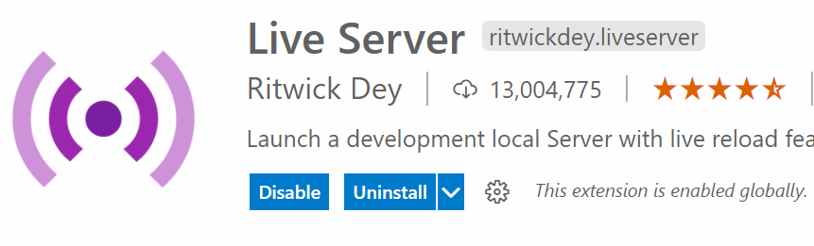
  + **Vscode-icons**

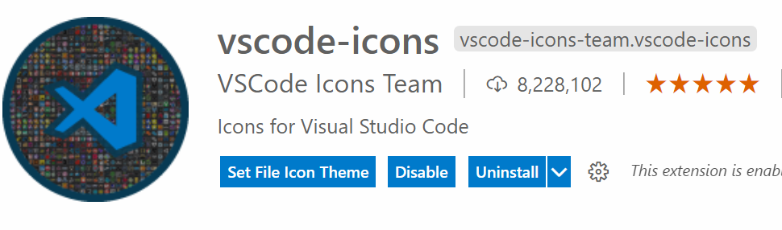

**What is Live Server / WebServer / HttpServer?**

* Webserver resembles both hardware and software
* It satisfies the client request by sending and receiving data.
* The popular webserver software
  + IIS [Internet Information Services Manager]
  + Tomcat [Apache]
  + Light TPD etc..

**Web Terminology**

* **Internet**
* **Web**
* **Web Server**
* **Web Site**
* **Web Application**
* **Web Page**
* **URL**
* **Protocol**
* **Blog**
* **Wiki**
* **Podcasting**
* **Widgets**
* **Web Debugger**
* **Web Browser**

**What is a Web Site?**

* Website is a **virtual** directory.
* It comprises of resources.
* It is all about Front-End

**What is a Web Application?**

* Web Application comprises end to end integration
* It is combination of both front end and back end.
* Client-Side and Server Side

**Creating a new Web Application**

* Open your PC locations “windows explorer”
* Create a new folder for your application  
  **C:\ShoppingApplication**
* Open **Visual Studio Code** editor
* Go to “File Menu -> Open Folder”
* Select your “ShoppingApplication” folder and Open
* Go to “Terminal” menu and select “New Terminal” or [Ctrl + ` ] backtick
* Run the following command “npm init”  
  **C:\ShoppingApplication> npm init**
* It will ask you to walk through the following questions, which will create a file called “**package.json**”  
  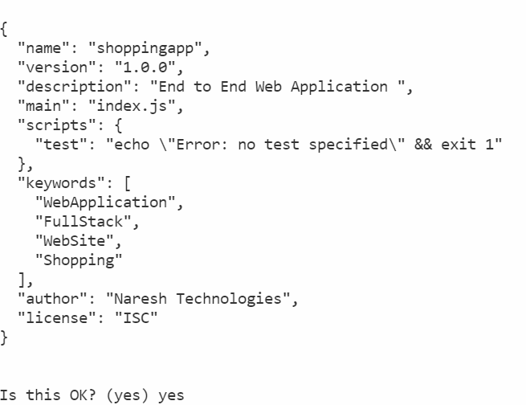

**Note: npm init** is a command used to configure a web application. [Initialization of Project]

**What is the purpose of “package.json” file?**

* Package.json contains meta data.
* Information about your project, which includes
  + Name
  + Description
  + Keywords
  + License
  + Author
  + Dependencies etc.

**JSON – JavaScript Object Notation – It is a format of presenting data / Information.**

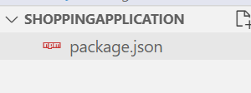

**Maintain Folder Structure for your application**

* Add following folders into Project
  + public
  + src
* **“public”** folder is used to maintain static resources of project
  + Html files,
  + Text documents
  + Images
  + Pdf documents etc.
* **“src”** folder is used to maintain dynamic resources of project
  + JavaScript Files
  + CSS Files
  + Sass / Less etc.

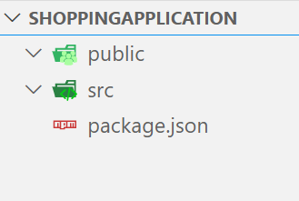

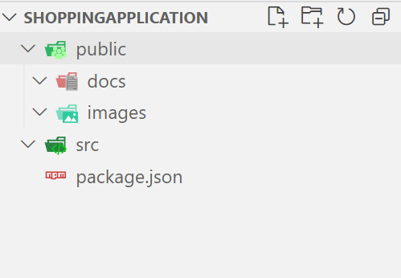

**What is Web Page?**

* Web Page is a Hyper Text Document.
* It provides a User Interface “UI” for website | application so that users can interact with the resources in website | application.

**What is Hyper Text Document?**

* The term “Hyper” is a Greek term, which means “beyond”
* It is a document that contains lot of information beyond what you see.

**Types of Web Pages?**

* Static Page
* Dynamic Page

**What is difference between Static and Dynamic Page?**

**Static Page:**

* It contains same information to display across any number of requests.
* It will have extension
  + .html
  + .htm

**Dynamic Page:**

* It contains information that can change according the client request.
* It can customize the content according to client request.
* Dynamic Pages require Server-Side Technology for configuring functionality.
* It will have extension
  + .jsp
  + .asp
  + .php
  + .aspx etc..

**HTML** is used to design both static and dynamic pages.

**What is difference between Web Site and Web Application?**

* Web Site comprises of all static resources.
* Web Application comprises of both static and dynamic resources.

**What is a Blog?**

* Term Blog is derived from “Web-log” [blog]
* Blogs are like journals on internet, usually published and maintained by individual users.
* Vlogs [Video Logs] – YouTube Channel
  + [www.blogger.com](http://www.blogger.com)

**What is a Wiki?**

* The terms “wiki” means “Quick”
* It is a Hawaii term
* “Wiki Pedia” – Quick reference for Encyclopaedia
* Wiki allows any user to edit its content.
  + WikiPedia
  + IMDB
  + Google Maps

**What is Podcasting?**

* The term “pod” refers to media content [Audio-Video]
* Podcasting is the process of broadcasting media on to other devices.
  + YouTube
  + iTunes
  + Windows Media Player
  + Spotify

**What is Widget?**

* Gadget for Web Application
* A widget is a small application tool integrated into webpage to handle various types of interactions
  + EMI Calculator
  + Currency Converter
  + BMI Calculator etc..

**What is a Web Browser?**

* Web browser is a software tool used to access web site, application, blogs etc. on client computer | device.
  + Chrome
  + Edge
  + FireFox
  + Internet Explorer
  + Safari etc..

**What is Web Debugger?**

* Web debugger is a software tool used to debug the web pages.
* Debugging is the process of identifying the bugs [issues] in page and resolving them.
* Every browser has debugger, you can open by using “Inspect Elements”
  + FireBug
  + Fiddler
  + Postman etc..

**What is URL and URI?**

* Uniform Resource Locator
* Uniform Resource Identifier
* URL is a virtual path used to access the resources from a website or application.
* URI is an identifier in the path.

<http://www.amazon.in/electronics.html> - URL

[http://www.amazon.in/**electronics.html#mobile**](http://www.amazon.in/electronics.html#mobile) - URI

<http://www.amazon.in/electronics/mobile> - **Routing**

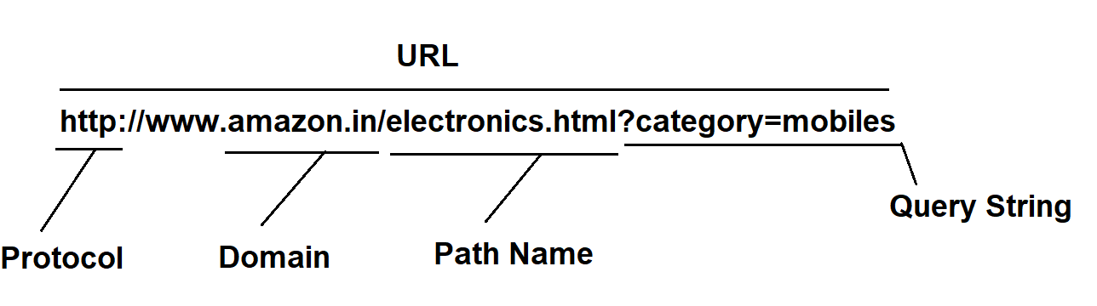

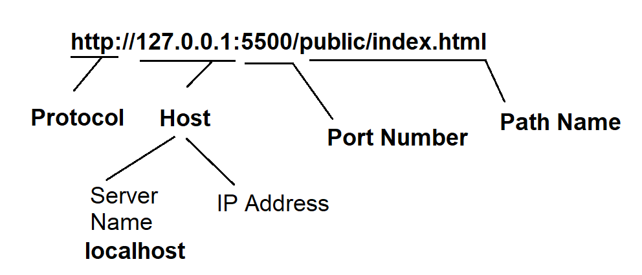

**What is Protocol?**

* Protocol defines set of rules for computers in a network to communicate with each other.
* Computers on Internet use
  + HTTP [Hyper Text Transfer Protocol]
  + HTTPS [HTTP Secured]
  + SMTP [Simple Mail Transfer Protocol]
* Computer on Intranet use
  + FTP [File Transfer Protocol]
  + File

**Domain Name?**

* Website or Application name.
* You have to purchase a Domain name.
* Domain extensions are according to the business or service of company
  + Com Commercial
  + Org Organization [non-commercial]
  + Edu Educational
  + Co.in Sub Domain [Indian]
  + Co.uk Sub Domain [Britan]
  + Nic National Informatic Center

**HTML – Hyper Text Markup Language**

**What is Hyper Text?**

* Specifies the text that contains content beyond what we see.

**What is Markup?**

* Markup is a general computer term derived from “Marking Up”.
* Marking Up means preparing form Presentation.
* Markup Language is a **presentation language**.
* It is used for preparing content to present exactly how we want on browser.
* GML – Generic Markup Language – CERN Labs
* SGML – Standard Generic Markup Language
* Tim Berners Lee introduced **HTML –** Hyper Text Markup Language in early 1990 for **Mosaic** Browser
* **IETF [**Internet Engineering Task Force**] 1993** – HTML
* **1995 HTML 2.0**
* **1997 HTML 3.2**
* **1997 HTML 4.0**
* **WHATWG [**Web Hyper Text Application Technology Work Group] and **W3C** World Wide Web Consortium 2013
* **2014 HTML 5.0**
* **2017 HTML 5.2**

**What is HTML?**

* HTML is a markup language.
* HTML is a presentation language.
* HTML is a collection of **Elements** arranged in a hierarchy [Parent – Child] called DOM.
* HTML presents content in Hierarchy called DOM [Document Object Model].
  + Image Element
  + Form Element
  + Table Element
  + Heading Element
  + Paragraph Element
  + Link Element

